Java Medical User Manual

When the user opens the program, the user should be able to see this on screen. This Is to let the user know that the user has open the program.

The user should be able to see three different options. Each option will take the user to somewhere different.

For Patients

The first part is the patient login. Click on the button that is circle to start.

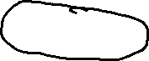

When the user presses the button, the user will see a blue background to indicate that the user is in the patient portal. The user will see the log in to put the users information like username/email and password where the circle is located.

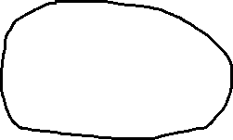

Once the user put your login into the field, hit the login button to go inside the program.



If the user is a new user, click on the Register button to start sign up.



If the user needs to return to the menu, click on the home icon below. This icon will take the user back to the beginning of the program.



Now, lets show how to register the user as a patient in the portal. First the user click on the register button that was shown earlier to take the user to the registration page. Once there, the user should see a page like this.Graphical user interface, application

Once, you get to this screen, fill out the information inside the field with the appropriate information.After the user put the information in, hit the register button below to finish.



For Employees

To start, click on the second button shown in the menu.



The user employee should see a brown login page to show that they are in the employee portal.

The user will enter their login credentials that was given to them by the employer. To log in, enter the username/email and password given by the employer then hit the login button.Graphical user interface, application

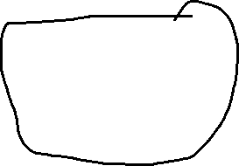

The user should be logged in to the program.

Exiting the Program.

To exit the program, simple click exit program in the main menu.



Once the user clicked the button, you are out of the program